Suggested Work Juniors Week 4
Monday
- Maths: Operation Maths p.69 (Put Teddy’s Day in order using numerals 1-5)
- Reading: Just Phonics (school workbook) p.45 (read and colour the sentence that matches the picture)
- Writing: Wow! Workbook p.21 (Call out words at random and your child colours the corresponding cloud, trace and read the sentence)
Tuesday
- Reading: https://www.oxfordowl.co.uk/api/interactives/24761.html “Dad’s Birthday”
- Writing: Wow! Workbook p.21 (Call out words at random and your child colours the corresponding cloud, trace and read the sentence
- Maths
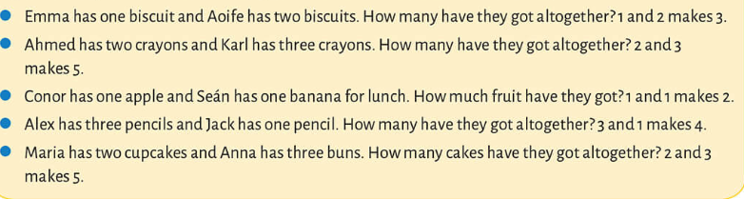
Wednesday
- Reading: https://www.oxfordowl.co.uk/api/interactives/24761.html “Dad’s Birthday”
- Writing: Wow! Workbook p.22 (trace, read and write)
- Maths
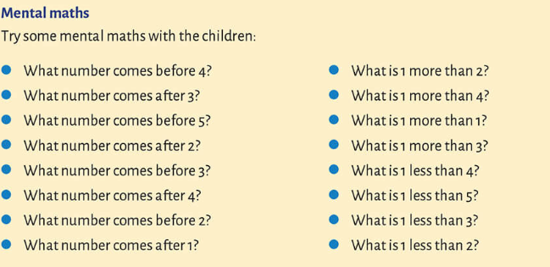
Thursday
- Reading: https://www.oxfordowl.co.uk/api/digital_books/1215.html ‘Big, Bad Bug’
- Workbook: Just Phonics (school workbook) p.48 (read and colour the correct picture)
- Maths Operation Maths p. 77
Friday
- Maths: Operation Maths p.78
- Reading: https://www.oxfordowl.co.uk/api/digital_books/1215.html ‘Big, Bad Bug’
- Workbook: Just Phonics (school workbook) p.49 (colour the picture with the correct sound)

